PYTHON Cognitive AI
https://courses.cognitiveclass.ai/courses/course-v1:Cognitiveclass+PY0101EN+v2/courseware/da924c023b9b4009972ea7f973a572b8/f2a42aed811f417cab4f0a064a469218/?child=first

Syllabus
Module 1 - Python Basics
  - Your first program
Python print statement does not print \n if in “”. Also print ("Hello there!", end = '') to avoid any new line
A=['A','B','C','D',1,'B','C','D']
for i,val in enumerate(A):
print(i,"-",val,end ="|")
OUTPUT 0 - A|1 - B|2 - C|3 - D|4 - 1|5 - B|6 - C|7 - D|
  - Types
Types are your Data types in python. We can know type of a variable by just typing type(value).
Integers Float Strings Boolean are different types in Python but Python is not data specific meaning we do not need to declare type whenever we declare a new variable.
Type Casting is done in python that is converting from one type to other. Ex. int (1.1) =1 and int(1.6)=1 and int(‘a’)=error.
MORE bool(1)=True and int(True)=1 (same for false==0)
TO print decimal range from float use this print("%.5f" % 3)
  - Expressions and Variables
Expressions are operations that python performs. Operands are numbers and operators are (+,-,*,/).
Python division / (float division) and // (integer division) ex. 3//5=0 and 3/5=0.6 Python follows hierarchy i.e. BODMAS
  - String Operations
String can be declared using single (‘) and double quotes (“). String can be accessed as array starting from 0 and individually access each character. Similarly, we can get last index as (-1).
Note: - Use square brackets to see individual on string. Also we can not change the individual letter by just assigning it.
String we can list like this var[2:5] so it will show only 2,3,4 letters not 5th one.
Another one is var[::2] indicates select every second letter i.e. 0,2,4,6 etc.
Using this we can also derives like this var[0:10::2] meaning in span of 0 to 9 select only 2nd letter.
LEN function and concat using + operator.
string*3 will show three times that same string.
ESCAPE SEQUENCES (\): -
\n is called new line escape sequence.
\t represents a tab space
\\ also shows single output in order to print forward slash
STRING METHODS: -
Strings are sequence and have apply method same as that
lists and tuples. Methods are some functions/operation that may help to get a new string. Note this function can only be used with string. Individual applied like in print statements these methods don’t work. Some of them are
- Upper() :- B=A.upper()
- Replace() :- ex. B=A.replace(‘substring’,’newstring’)
- Find() :- finds the index of string i.e. lowest index of given string. IF string is not found in variable then output is -1.
- Rfind() finds the character from left hand side.

Module 2 - Python Data Structures
  - Lists and Tuples
Tuples are data in parenthesis () that are ordered sequences. Tuple does not require its value to have fix data type. When you print type(tuple) output is tuple. Tuple also follows index starting from 0 and reverse starting from -1. We can combine/concatenate tuple by +. Same as above tuple [2:5] and tuple[::2]. Note length of tuple and index of tuple has -1 difference i.e. 0 to len-1 of tuple is index. Note Tuples elements also access using square bracks only. Tuples are immutable, which means we can't change them. In order to change them we assign a new tuple and provide there the necessity changes.
Nesting in Tuples :- Tuples can carry tuples in them ex.
ARR=[‘34’,’A’,7,(1,2,4,’J’),7,0,’rtg’] so if I want to print ‘J’ then I will write ARR[3](1,2,4,’J’)[3]=ARR[3][3]=’J’.
List are also ordered sequence with [] brackets. Only difference is that list is mutable. Meaning its elements can be modified. It can have str, float,bool, Tuples and List in them. Nesting is same as tuples. We can use method in List ie. Extend so ARR.extend([‘A’,’6’,”fj”]). Similarily if we write append then Arr.append([‘A’,6]) then only one elements add in ARR and that element is List ([‘A’,6]). Ex:- [‘34’,’A’,7,(1,2,4,’J’),7,0,’rtg’,[‘A’,6]].
Also change element and delete any element ex. del(A[0]) or Arr[0]=7
Method split() work on string only and by default delimiter is space else we can give delimiter ex. C="R,U,P,A,L".split(",").
Aliasing can be done like this C=B thus same list is pointed by C and B but if we try to change any list both list is gonna change so if we want to clone then clone like this C=B[:].
help(B) gives us number of methods that can be performed on list. Sort, reverse etc. and
  - Sets
Sets are also type of collections meaning u can add different types here. Unlike tuples and list unordered i.e. they don’t have index number to query. Also only one unique element is stored here so no duplicity. They are stored using {}. Type casting can be done here. We can get set from list/tupple using function set(). Example R=set(A). Note list/tuples/sets are objects and there attributes are defined using B.append() or B.sort() etc. but set is function so you can not treat like this R=A.set() error. SET use logic same as venn diagram. R.add('Z') and R.remove('A') are some of its methods.
C=R&B D=R.union(B) are two ways to show intersection and union of two sets.
  - Dictionaries
Dictionaries are also type of collection similar to list. In list we have index and elements here in dictionaries we have key and value pairs. Key are address and they are not necessarily integers. Keys are immutable and unique. IT is defined as this Dic={"rupal":"RLA190","NAM":"North America","ASIA":"ASIA",36:"The Number"}. We can add or del any element here using Dic[37]=”Next Number” or del(Dic[36]). In command gives true or flase if we search for any key in given dictionary. Also, we can use command Dic.keys() or Dic.values() to print the key and value of dictionary.
Module 3 - Python Programming Fundamentals
  - Conditions and Branching
Comparison operators (== , != , >, <) Float and int comparison operator.
Branching:- If statements will be written like
if condition :
elseif:
else:
Brackets can and can not be necessary. Python will understand it.
Logic Operator: - (works on Boolean Operators only)
Not operator not(True)=False
Or Operator or() and AND operator and()
  - Loops
(For and WHILE LOOPS ONLY)
Range Function i.e range(value) output ordered sequence from 0 to value-1. If two inputs then range(value, value2) then output value,…value2-1.
Enumerate function helps us get index and value of a list or tuples where 1st variable is assigned to index and 2nd variable is assigned to value.
  - Functions
Built in functions and how to build one functions. Function is piece of code which we reuse.
Sorted function and Sort Function :- Sorted function helps to get a sorted list assigned to a new list/tuple. But when you use sort function like A.sort() It will sort the A tuple/list only.
Note that when you multiply int by float you get output float. Python is designed for coders convenience. You defined a function using
def name(parameters,parameters):
return parameters as well
If we do not write return statement then it will do nothing simply if we put print statement then it will return that print statement.
def nowork_1():
pass
print(nowork_1())
output for this statement is none. Meaning if you wirte pass out put will be passed. And since you have not return it shows output none.
If we define function as def name(*names) * indicates that you can pass multiple parameters when function is called.
Global Scope meaning whatever you defined here is global. Example global variable which is then passed into function without defining.
Local variable exist till only scope of variable.
https://www.youtube.com/watch?v=8A9uAgqdzS0&feature=youtu.be >> Last 5 min to show how out put of global and local variable are pulled.
WE can define global variable in local scope by using GLOBAL keyword.
  - Objects and Classes https://www.youtube.com/watch?v=D9b2L_mlFv0
There are different data types are there.
Each has a var called as object.
Object has a type, internal data representation , methods.
Example :- when we define 5 integer objects/variable then we are creating 5 integer instances.
A method are functions that every instance of that class or type provide.
object.method() == A.sort()
WE can create our own class/type of that object. Class has data attributes and methods associated with it. Class and type are similar.
We can define our own class using class function
class circle(object):
def _init_(self,radius,color):
self.radius=radius
self.color=color
def add_radius(self,r):
self.radius=self.radius+r
return (self.radius)
dir(nameofobject) return list of attributes of that object. The under score around it are for internal use and should not consider.

_init_ is a special constructor used to initialize data attributes. Radius and color are new data attributes of class circle instance. SELF is box that consists all attributes of any object thus it is defined such.
Now we create objects of those instance i.e. variables pf that class.
We can define the method of this class as well by defining a function here.
Module 4 - Working with Data in Python
  - Reading files with open
Reading Files can be done with many of the examples. We will create a file object to read a file and then apply methods like read , write to make alterations in data of that object.
File1(object)=open(“location”,r/w/a(mode)). But remember it will not close file thus you will need to use close method to close it. File1.close.
With command is commonly practiced as it has in built function to close a file.
  - Writing files with open
- with open("Example1.txt","r") as file1:
- FileContent=file1.readlines()
- print(FileContent)
with open("Example2.txt","w") as writefile:
writefile.write("This is line A\n")
writefile.write("This is line B\n")

- with open("Example3.txt","a") as file1:
- file1.write("This is line C\n")

  - Loading data with Pandas
https://www.youtube.com/watch?time_continue=130&v=snLzicc9q90
Check the notebook for more examples. 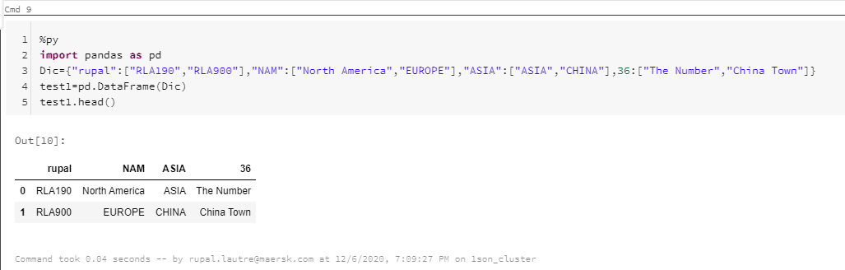
So this how data frames work just imagine a dictiory having key and value pairs. Key are columns and values are your row elements
Df.head() direct prints the top 5 rows of dataframe. You need not wirte any print statement
Creating Df from a existing one is easy as ex:
new=df[["rupal",36,"NAM"]] #brackets have column names
df.loc[1,"rupal"]/df.ix[1,"rupal"] #looking at specific data entry in data frame.
you can access the same using df.iloc[1,1]/df.ix[1,1]. Where df.iloc[row][column]
You can slice and set new DF using this command z=df.iloc[0:1,0:1]

  - Working with and Saving data with Pandas
https://www.youtube.com/watch?v=UfUSSIBQUOE
df.to_csv("file.csv") we can use this command to save a file into csv.
You can create a new data frame out of existing one by using this command pf=df[["reporting_week","Time_bckt_ID","Time_bckt_cd"]] where you give column names in it.
Also you can set filters like this and save the data. cf=pf[pf["Time_bckt_ID"]>=36]

Lab Notebook Link :-
https://eu-gb.dataplatform.cloud.ibm.com/analytics/notebooks/v2/fac25222-aed4-4adc-bbef-045cb0c1d27f?projectid=2878b90c-e0c4-4471-9c36-051bbe39f653&context=cpdaas

  - Simple APIs Part 1
https://www.youtube.com/watch?v=MlM00ZK27lY
Application program interface.
Libraries
API lets communication of data between two programs be that your pyspark code to check pandas library(which is set of software codes written) and take their data/function to use it. For example if you assign a table/file/dictionary to a variable and using df=pd.dataframe instance(var_name) you send your data in pandas using pandas API. Later when you use this dataframe for different methods like df.mean(), pandas will return you values having mean in that table.
REST API :- API that communicates using internet/HTTP. Representational State Transfer . Receiver is called the client and web service which is communicated using internet. Request is usually transmitted using http method which has data in JSON format (dictionary in py) This data has operation that we need to perform and other data/info required for our code. Response is received back to client in same http method in JSON format.
  - Simple APIs Part 2
There is a lab here where we use AI tool to process a Language wave file to convert that speech to text and then translate the same into another language.
API contact web service using API keys to verify the user called and what user have asked for. API key should be secret because it is charged. (gmaps API)
  - API Set up

Module 4 - Working with Numpy
  - Numpy on 1D Array
Numpy is used for scientific computing and has good speed.
- The basic and array creation
Python array or list is same. Numpy array is similary to list. Mutable and aliasing etc. We can assign the same by using a=np.array([0,1,2,3,4]). WE can access each integet with index and square brackets. You can view it’s data type and stored value data type as follows type() , a.dtype.
NOTE Array concept similar to C, where data type is consistent no different.

- Indexing and slicing
Indexing and slicing similar to list such as
a[0]=100 #out : array([100, 1, 2, 3, 4])
d=a[::2] #out : Out[12]: array([100, 2, 4])
c=a[1:4] #out : Out[11]: array([1, 2, 3])
- Basic Operation
Euclidian Operation or Vector Operation used for Data Science.
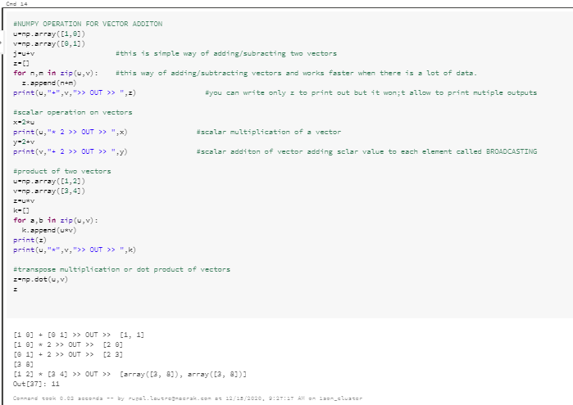
- Universal Function
mean() and max value i.e. max()
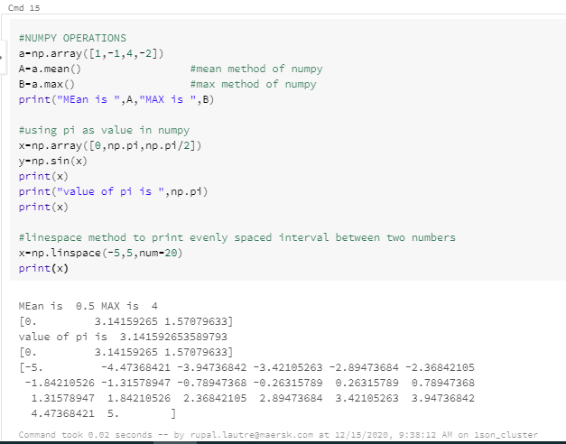

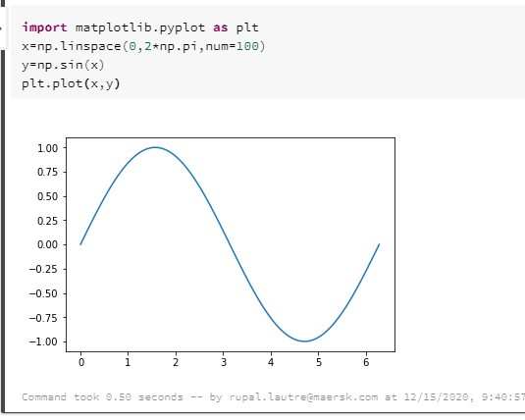
  - Numpy on 2D Array
- Basic creation of 2D
Crearting 2d arra is A=[[]] like this it’s like matrix.
the function ndim is a function where you see array dimension. You above example is 2 dim array it responds to x and y axis representation of that array. Shape function outputs the nxm of that array in rectangular representation.
- Slicing and Indexing of 2D
- Basic Operation of 2D
